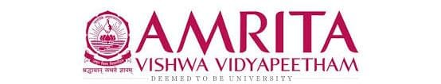

DATA STRUCUTRES AND ALGORITHMS
23CSE203
LAB MANUAL

Submitted by

Name | PRANAVI AYYAGARI
Roll No | AV.SC.U4CSE25012
Year/Sem/Section | 2nd year/Sem-3/CSE-A
Credits | 05

Submitted to

Name | Dr. RAJ KUMAR BATCHU
Department | School of Computing
Designation | Asst. Professor (SI Grade)
S.NO | TITLE | PAGE NO | REMARKS
1. | WEEK 1: 1a. Recursive countdown from n to Launch.  1b. Recursive calculation of compound growth factor.  1c. Recursive search for employee ID in list.  1d. Recursive factorial calculation for parcel arrangements.  1e. Recursive Fibonacci series generation. | 3 - 11
2. | WEEK 2:
3. | WEEK 3:
4. | WEEK 4:

WEEK – 1
1a. AIM: A rocket launch system displays a countdown before launch. Instead of using a loop, implement the countdown using recursive. Write a recursive python program to display a countdown from n to 1, followed by “Launch”.
PROGRAM:
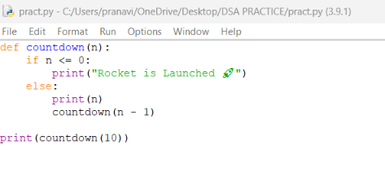
OUTPUT:
Positive Case;
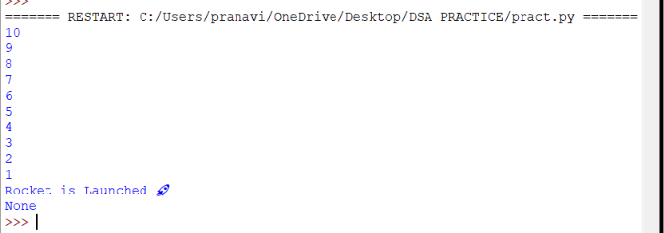
Negative Case;
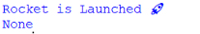

EXPLANATION:
Condition 1: Positive Input (n > 0)
- The function checks if n <= 0. Since n is positive, this condition is False.
- It executes the else block:
  - Prints the current value of n.
  - Calls itself recursively with n - 1.
- This repeats until n becomes 0.
- Finally, when n = 0, the condition n <= 0 becomes True.
- After the recursive calls finish, the function returns None (since no return is defined).
- The calling print (countdown (10)) will display the countdown, the launch message, and then None.
Condition 2: Negative Input (n <= 0)
- The condition if n <= 0 is immediately True.
- It directly prints:
Rocket is Launched
- No recursion happens because the else block is skipped.
- The function ends and returns None.
- The calling print (countdown (-1)) will display:
Rocket is Launched
None
ERROR TABLE:

S.NO | Error Obtained | Rectification
1. | Syntax Error  Forgot to give “:” in the control statement. | Later it was rectified by giving the “:”
2. | Type Error  I have entered a non – integer. | It was rectified by passing only the integers.

1b. AIM: Banks calculate the growth of an investment using compound interest. The formula requires calculating powers, which can be implemented recursively. Write a recursive program to calculate P^{n}(power), Where p = principal growth factor, n = number of years.
PROGRAM:
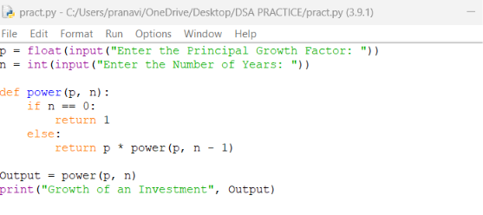

OUTPUT:
Positive Case;
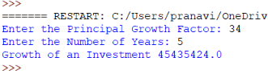
Negative Case; 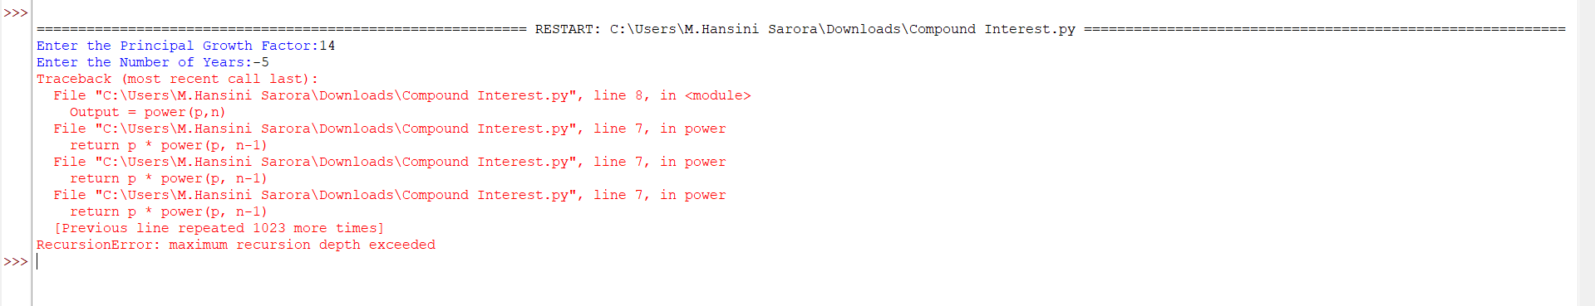

EXPLANATION:
Condition 1: Positive Input (n ≥ 0)
- User enters a positive number of years (e.g., n = 3).
- The function checks if n == 0. Since n is positive, this is False.
- It executes the else block:
  - Multiplies p by the result of power (p, n-1).
- Recursion continues until n becomes 0.
- At n = 0, the base case returns 1.
- The recursive calls unwind, multiplying p repeatedly.
- The output is $p^{n}$, i.e., the growth factor raised to the number of years.
Condition 2: Negative Input (n < 0)
- User enters a negative number of years (e.g., n = -2).
- The function checks if n == 0. Since n is negative, this is False.
- It executes the else block:
  - Calls power (p, n-1) with an even smaller negative number.
- Recursion continues indefinitely (-2 → -3 → -4 → …).
- The base case (n == 0) is never reached.
- Python raises a “Recursion Error: maximum recursion depth exceeded.”
ERROR TABLE:

S.NO | Error Obtained | Rectification
1. | Floating-Point  I have entered a floating-point value in the years. | Later it was rectified by giving the integer value.
2. | Large Input Error  I have given a huge input value. | It was rectified by passing default limit of Python.

1c. AIM: An HR department stores employee IDs in a list. Develop a recursive program to search for a given employee ID. Write a recursive function to search for an employee ID in a list.

PROGRAM:
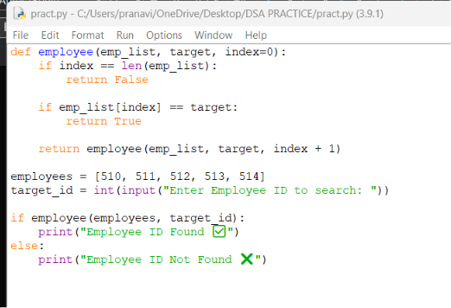

OUTPUT:
Positive Case;
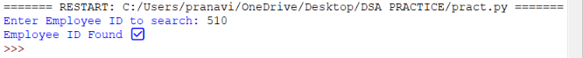
Negative Case; 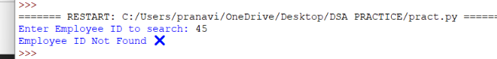

EXPLANATION:
Condition 1: Employee ID Found
- The function starts at index 0.
- It compares emp_list[index] with the target.
- If a match is found, the function immediately returns True.
- The recursion stops early — no need to check further elements.
- The main program prints:
Employee ID Found ✅
Condition 2: Employee ID Not Found
- The function checks each element recursively.
- If the end of the list is reached (index == len(emp_list)), the base case returns False.
- The recursion unwinds, propagating False back to the main program.
- The main program prints:
Employee ID Not Found ❌
ERROR TABLE:

S.NO | Error Obtained | Rectification
1. | Empty List  I haven’t entered the values in the list. | The empty list was filled with the emp IDs.
2. | Logical Error  I have entered the duplicate values. | It was rectified by removing the duplicates.

1d. AIM: In a logistics company, the number of possible ways to arrange n different parcels is calculated using the factorial formula (n!). Develop a recursive program to calculate the factorial of a given number.
PROGRAM:

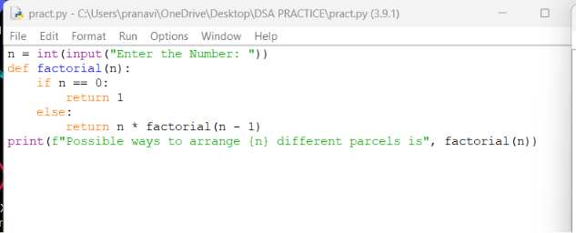

OUTPUT:
Positive Case;
Negative Case; 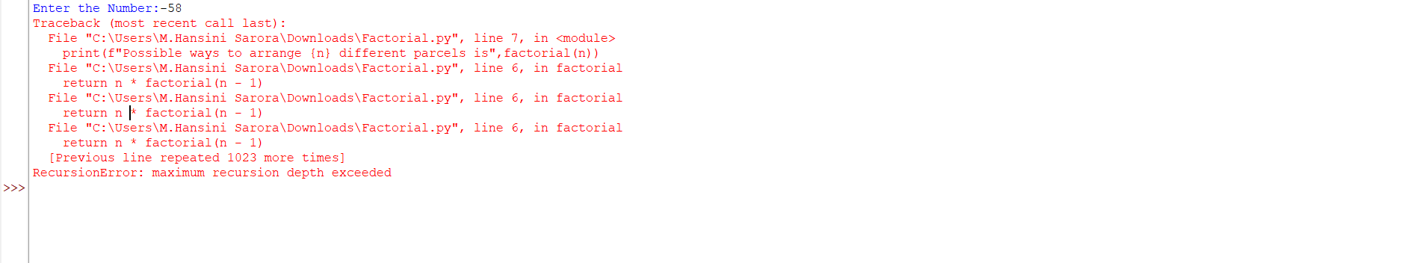

EXPLANATION:
Condition 1: When n == 0
- The function checks:
if n == 0:
return 1
- By definition, $0!=1$.
- So if the user enters 0, the program outputs:
Possible ways to arrange 0 different parcels is 1
Condition 2: When n > 0
- The function executes:
else:
return n * factorial(n - 1)
- This means the function calls itself with a smaller number until it eventually reaches n == 0.
- Uses recursion to multiply numbers down to 1.

ERROR TABLE:

S.NO | Error Obtained | Rectification
1. | Negative Input  I haven’t entered the negative value. | Later, It was rectified by entering positive values.
2. | Large Input Error  I have entered a very large number. | It was rectified by entering limited values.

1e. AIM: Write a recursive python program to print the first n yerms of the Fibonacci Series.
PROGRAM:
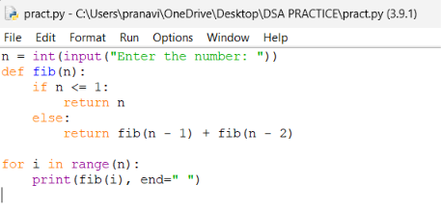

OUTPUT:
Positive Case;
Negative Case;

EXPLANATION:
Condition 1: When n <= 1

- Inside the function:
if n <= 1:
return n
- This is the base case of recursion.
- If n = 0, it returns 0.
- If n = 1, it returns 1.
- These are the starting points of the Fibonacci sequence..
Condition 2: When n > 1
- The function executes:
python
else:
return fib(n - 1) + fib(n - 2)
- This means the Fibonacci number at position n is the sum of the two previous numbers.
- The recursion keeps breaking down until it reaches the base case (n <= 1).
ERROR TABLE:
S.NO | Error Obtained | Rectification
1. | Negative Input  I haven’t entered the negative value. | Later, it was rectified by entering positive values.
2. | Very large input  Recursion depth exceeded. | It was rectified by entering limited values.

WEEK-2
- AIM: Write a python programm to perfor linear search on the given input.
Program:
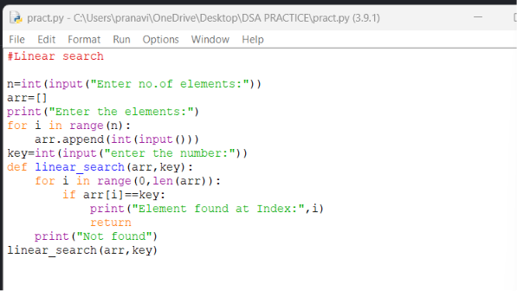
Output:
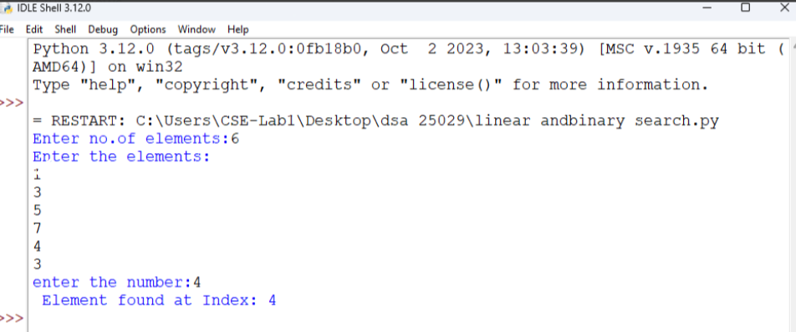

Explanation:
- In linear search we can append elements in sorted or unsorted way also.
- After placing the target we need to check the all the elements in a order.
- The time complixity is O(n).
- The target element may be found at beginning or last or at middle.
Error table:
s.no | Error obtained | Rectification
1. | Return placed in wrong place | Corrected later
2. | Calling the function | Rectified

B) Aim: Write a python program to perform binary search on the list.
Program: Unsorted
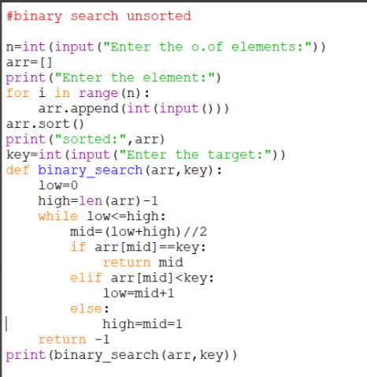
Output:
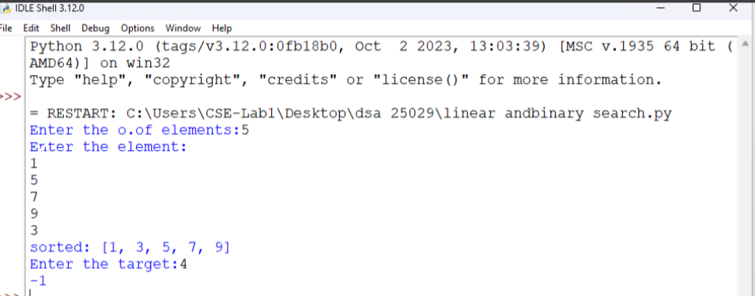

Program: Sorted
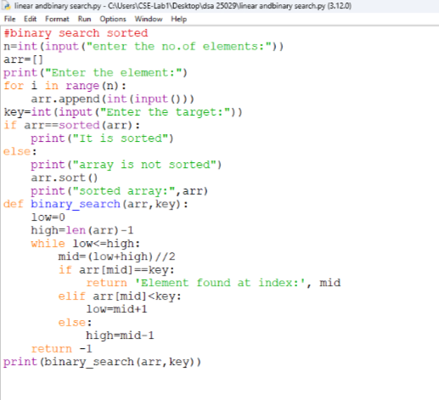
Output:
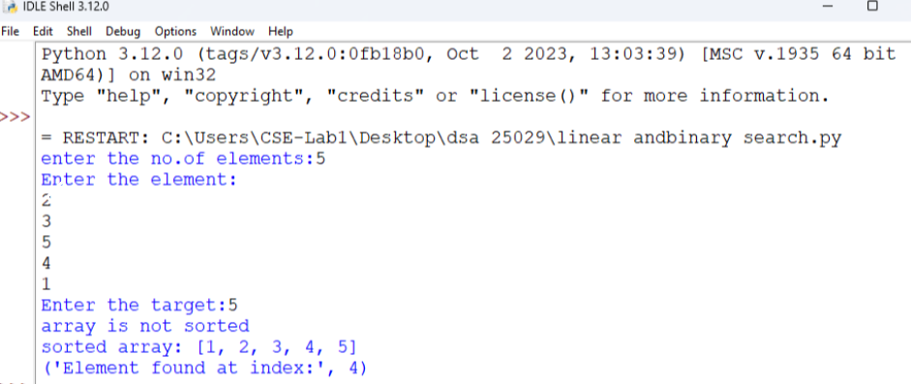

Explanation:
- The binary search should always executed in sorted order.
- Either it can be ascending or descending order.
- So the program is in unsorted order so we need to do sorting first later the binary search is executed.
- Error table:
s.no | Error obtained | Rectification
1. | Mistakes in main logic | Rectified
2. | Errors in conditions | Rectified

WEEK-3
A)Aim: Write a python programme to sort the elements using a bubble sort technique. Take an input elements from the users.
Programme:
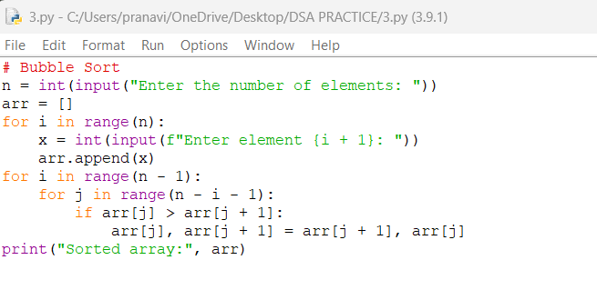
Output:
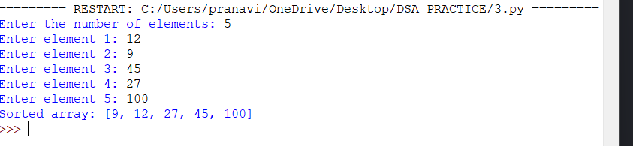
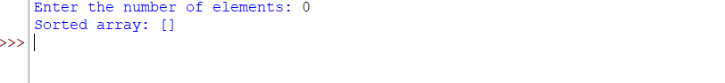

Explanation:
- n stores the number of elements, and an empty list arr is created.
- The first for loop takes n numbers from the user and adds them to arr.
- The second loop controls how many times the sorting process is repeated.
- The inner loop compares two neighboring elements: arr[j] and arr[j+1].
- If the first element is bigger, they are swapped using arr[j], arr[j+1] = arr[j+1], arr[j].
- Finally, print() displays the array in ascending order.
Error table:
s.no | Error obtained | Rectification
1. | Mistakes in main logic | Rectified
2. | Errors in conditions | Rectified

B)Aim: Write a python programme to sort the elements using a insertion sort technique. Take an input elements from the users.
Programme:
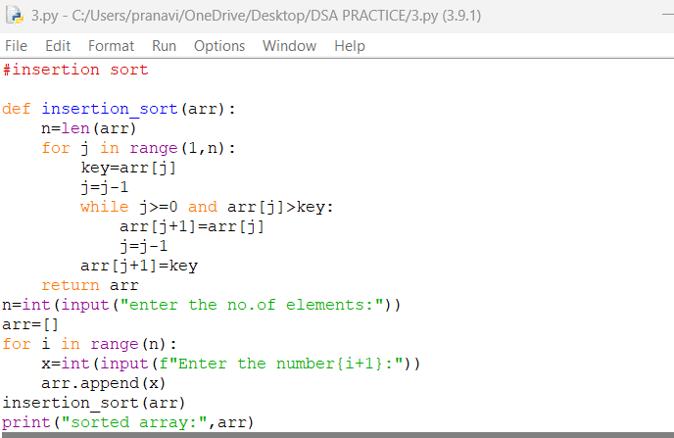
Output:
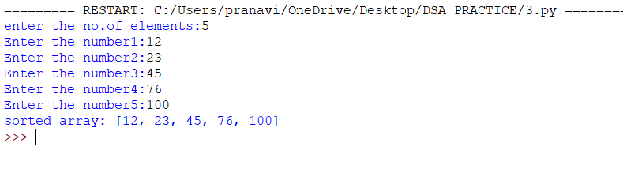

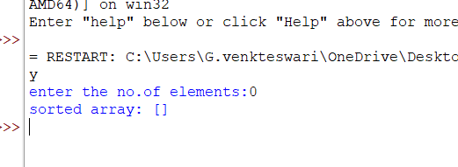
Explanation:
- insertion_sort(arr) takes the array and finds its length using n = len(arr).
- The for loop starts from the second element because the first element is considered already sorted.
- key = arr[j] stores the current element that we want to place in the correct position.
- The while loop moves bigger elements one position to the right.
- arr[j+1] = key places the current element in its correct position.
- Finally, the function returns the sorted array, and print() displays it in ascending order.
Error table:
S.no | Errors | Rectification
1. | Error in main logic | Rectified
2. | Errors in condition | rectified

C)Aim: Write a python programme to sort the elements using a selection sort technique. Take an input elements from the users.
Programme:
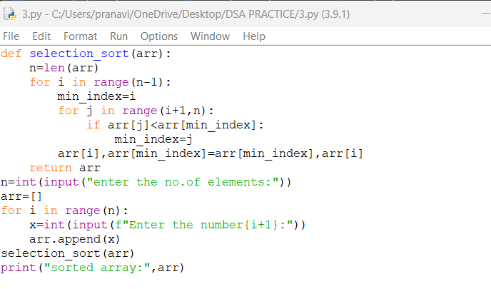
Output:
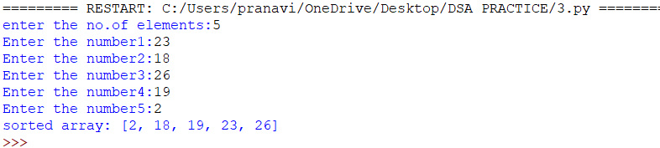

Explanation:
- n = len(arr) finds the total number of elements in the array.
- The outer for loop selects each position where the smallest element should be placed.
- min_index = i assumes that the current position contains the smallest element.
- The inner for loop compares the remaining elements and finds the smallest element's index.
- arr[i], arr[min_index] = arr[min_index], arr[i] swaps the smallest element with the current element.
- After all iterations, the array is sorted in ascending order and print() displays it.

Error table:
S.no | Errors | Rectification
1. | Error in main logic | Rectified
2. | Errors in condition | rectified

D)Aim: Write a python programme to sort the elements using a merge sort technique. Take an input elements from the users.
Programme:
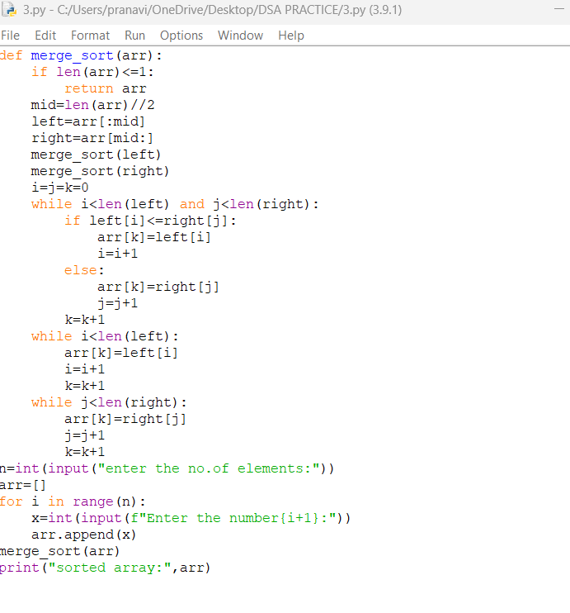
Output:
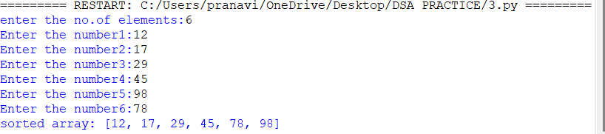
Explanation:
- if len(arr) <= 1 checks if the array has 0 or 1 element; if yes, it is already sorted.
- mid = len(arr)//2 finds the middle and divides the array into left and right parts.
- merge_sort(left) and merge_sort(right) recursively divide both parts into smaller parts.
- i = j = k = 0 creates indexes to compare elements from the left part, right part, and original array.
- The while loops compare elements and put the smaller element first into the original array.
- Finally, the remaining elements are added, and print() displays the sorted array in ascending order.
Error table:
S.no | Errors | Rectification
1. | Error in main logic | Rectified
2. | Errors in condition | rectified

E)Aim: Write a python programme to sort the elements using a merge sort technique. Take an input elements from the users.
Programme:
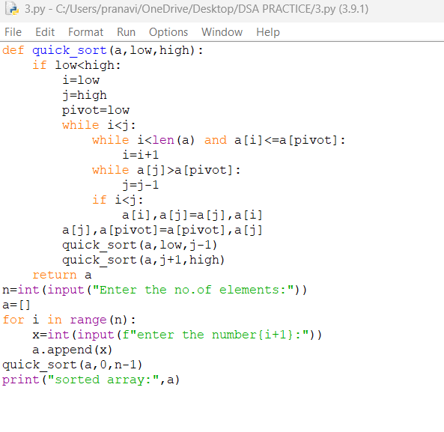
Output:
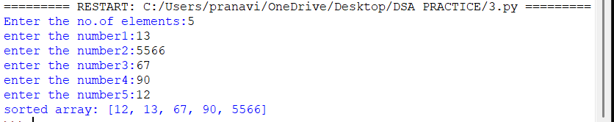
Explanation:
- quick_sort(a, low, high) sorts the elements between the low and high indexes.
- pivot = low selects the first element as the pivot.
- i moves from the left and finds an element greater than the pivot, while j moves from the right and finds an element smaller than or equal to the pivot.
- If i < j, a[i] and a[j] are swapped.
- After the loop, a[j] and the pivot are swapped, putting the pivot in its correct position.
- quick_sort() is called again for the left and right parts, and finally the array is printed in sorted order.
Error table:
S.no | Errors | Rectification
1. | Error in main logic | Rectified
2. | Errors in condition | rectified

LAB -4
Aim 4.a:Write a program to implement a single linked list which would perform the below operations, by taking an input from the user.
a)create a linked list
b)insert at beginning
c)insert at end
d)insert at a specified index
e)delete by value
f)delete 1st node
g)delete last node
h)count no.of nodes
i)display or traverse
j)search for a number
k)exit
Program:

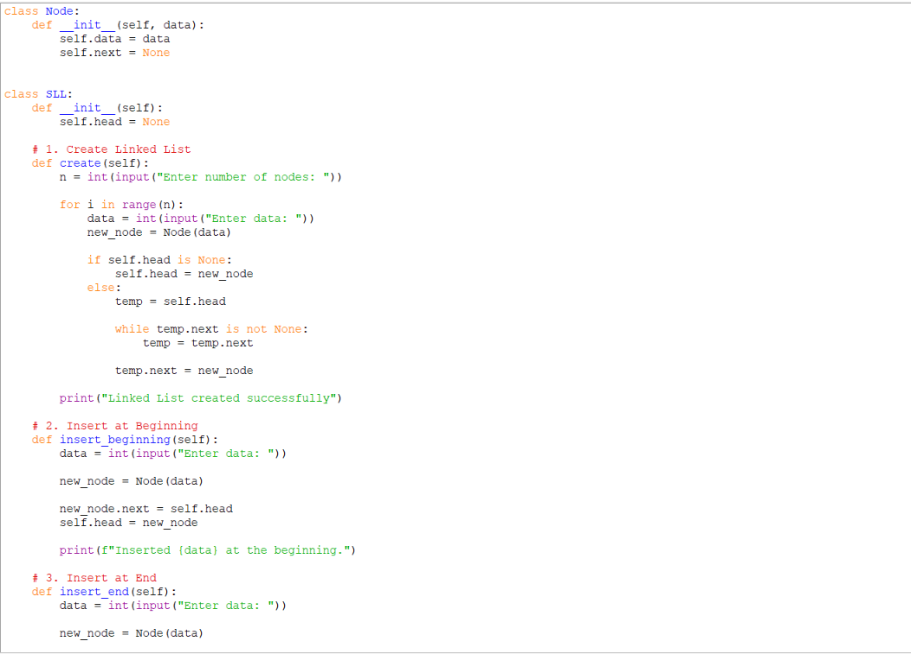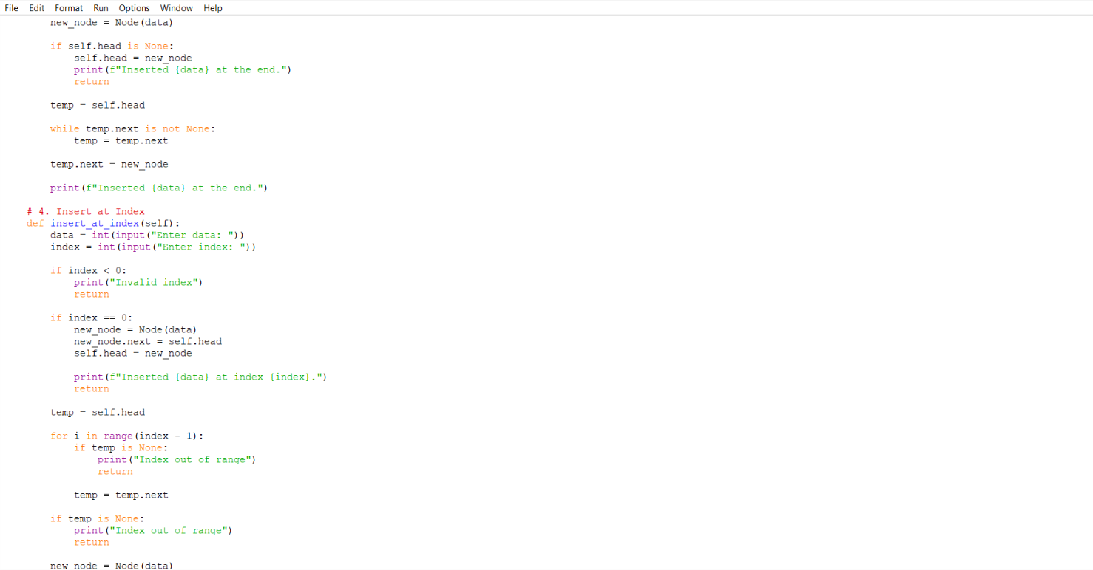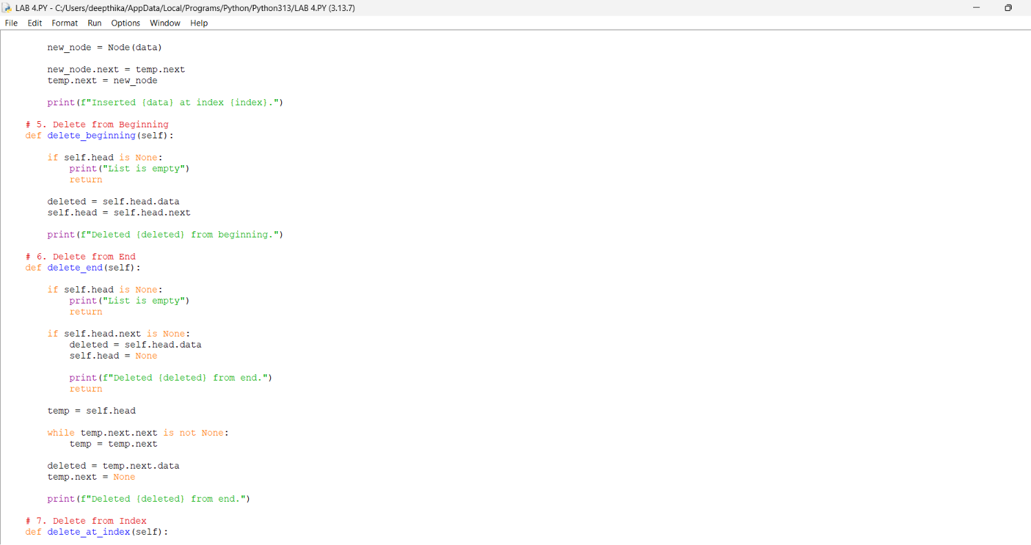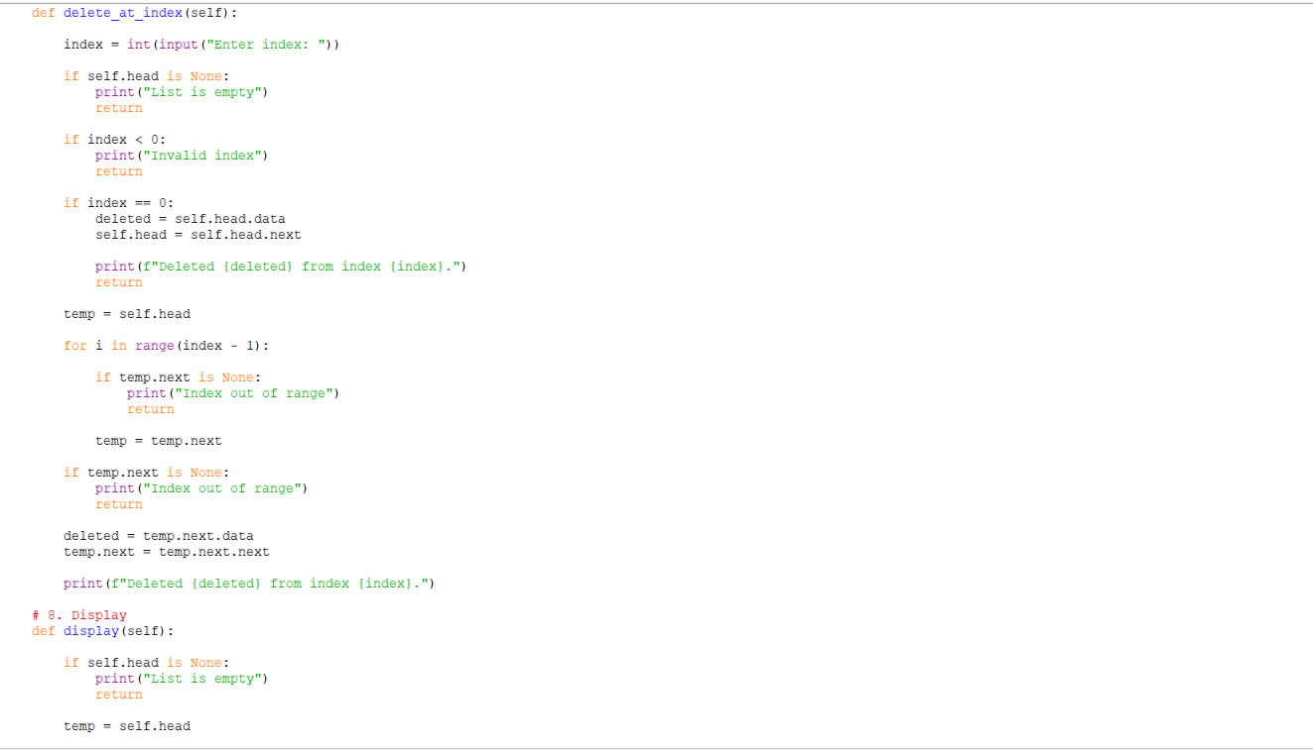
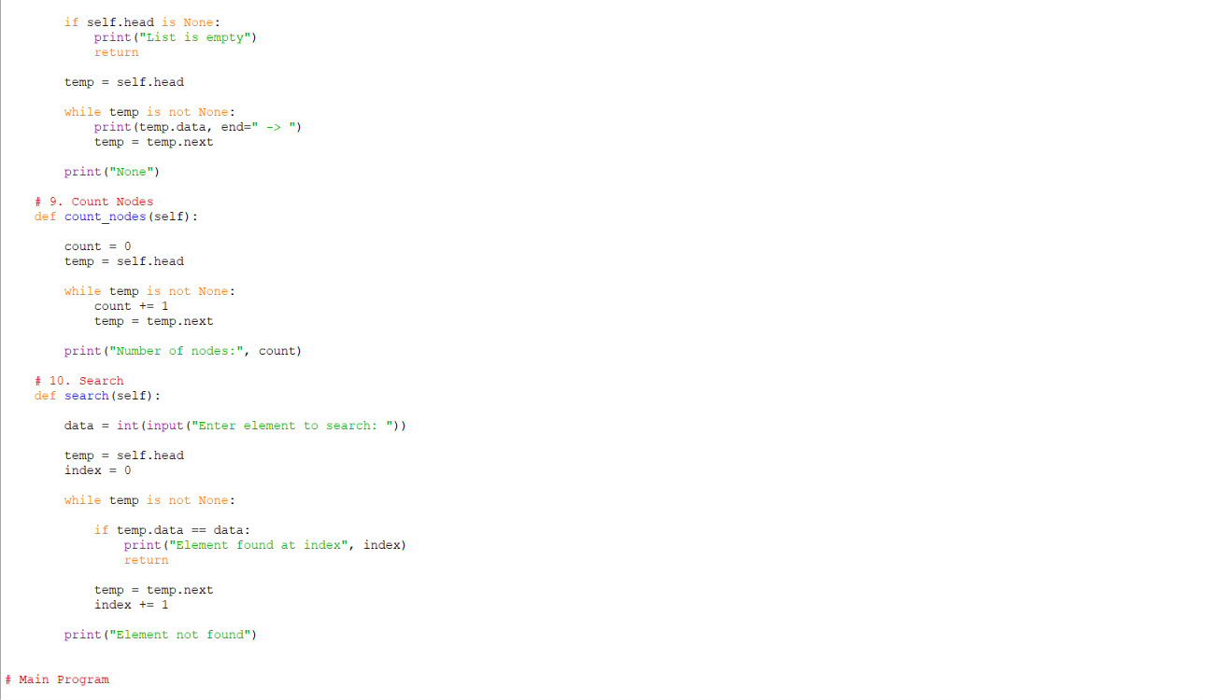
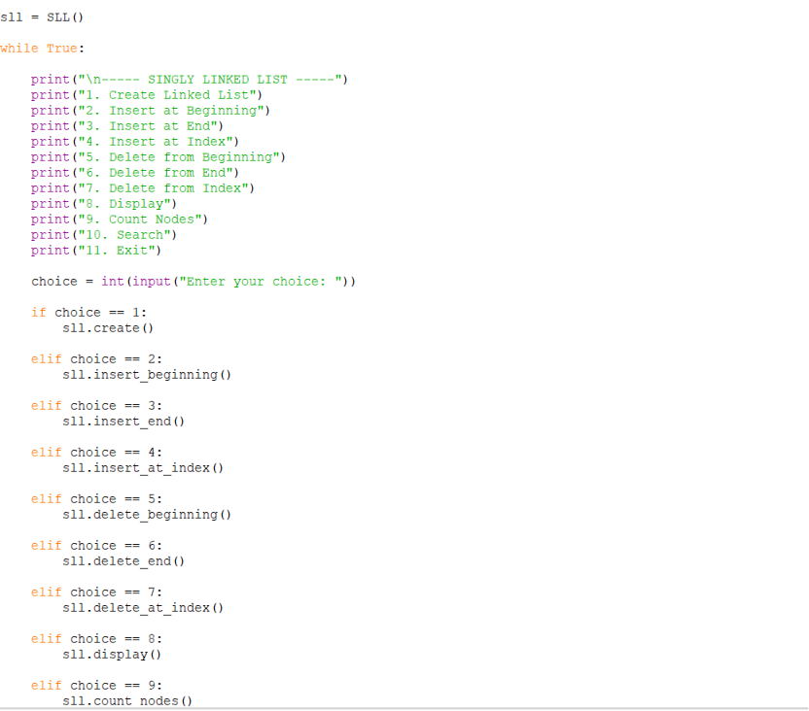

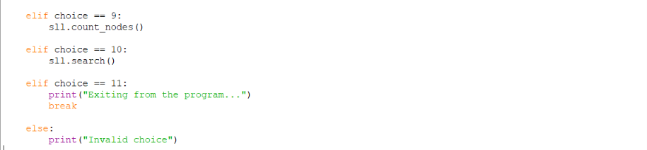
Output:
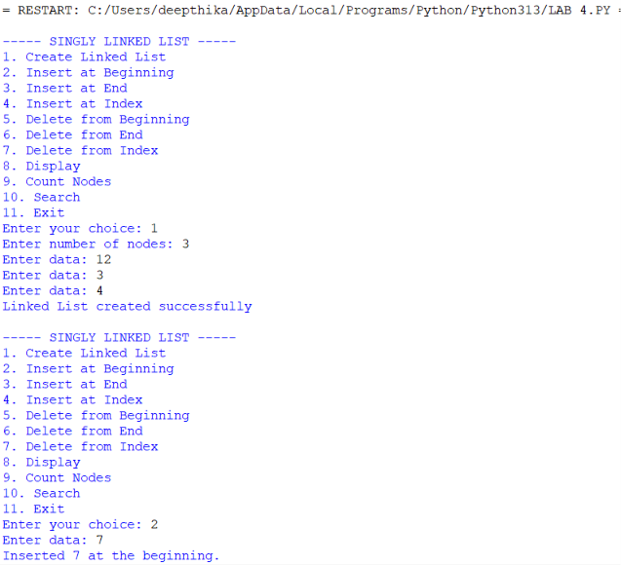
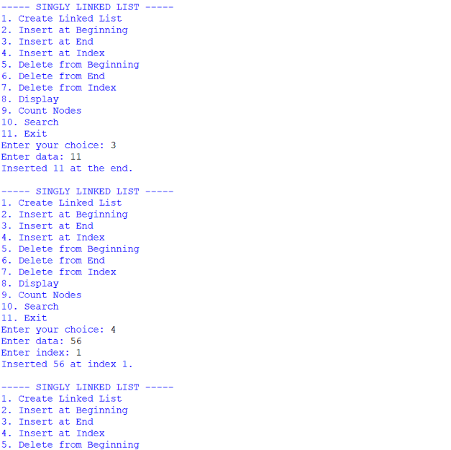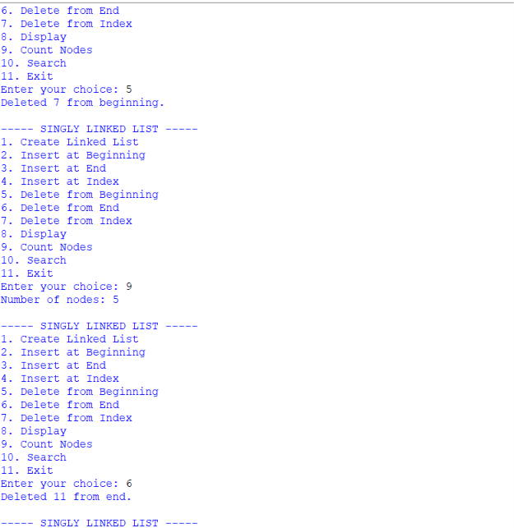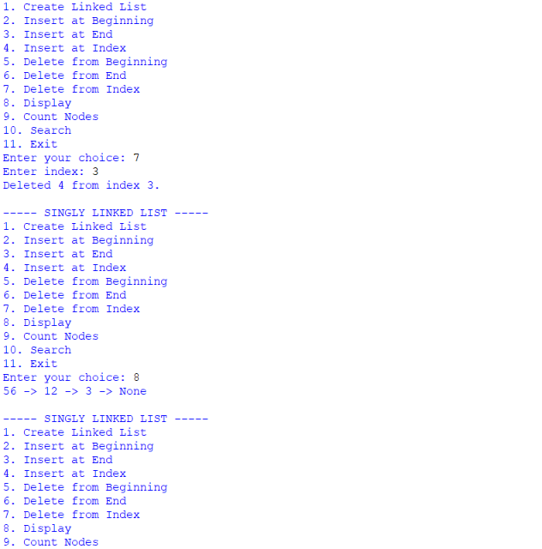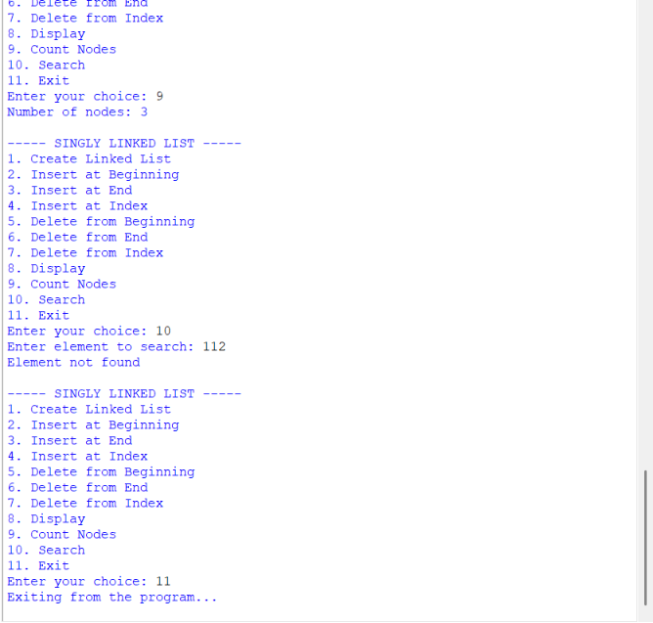
Explanation:
A Singly Linked List (SLL) is a linear data structure in which each node contains two parts: data and a next pointer. The data part stores the value, while the next part stores the address/reference of the next node. The head pointer points to the first node of the linked list. The last node points to None, indicating the end of the list.
The program implements the following operations:
- Create Linked List: Creates a linked list by taking the number of nodes and their data from the user. Each new node is connected to the previous node.
- Insert at Beginning: Creates a new node and makes it the first node by changing the head pointer.
- Insert at End: Traverses the list until the last node and connects the new node to it.
- Insert at Index: Inserts a new node at a specified position by adjusting the links between nodes.
- Delete from Beginning: Removes the first node by moving the head pointer to the next node.
- Delete from End: Traverses to the second-last node and changes its next pointer to None.
- Delete from Index: Removes a node from a specified position by changing the next pointer of the previous node.
- Display: Traverses the complete linked list and displays each node's data.
- Search: Traverses the list and checks each node to find the required element. It also displays its index if found.
- Count Nodes: Traverses the list using a temporary pointer and increments count for every node until None is reached.
- Exit: Terminates the program.
The program uses a menu-driven approach, allowing the user to select and perform different linked-list operations repeatedly.
ERROR TABLE :
PROGRAM | ERROR / PROBLEM | CAUSE | CORRECTION
1. Create Linked List | List is not created properly | head or next links are not initialized correctly | Initialize head = None and connect each new node using next.
2. Insert at Beginning | New node is not inserted at the beginning | head is not updated correctly | Set new_node.next = self.head and then self.head = new_node.
3. Insert at End | New node is not added at the end | Traversal or next assignment is incorrect | Traverse until temp.next is None and set temp.next = new_node.
4. Insert at Index | Node is inserted at the wrong position | Incorrect index traversal | Traverse up to index - 1 and adjust the next links.
5. Delete from Beginning | First node is not deleted | head is not moved to the next node | Set self.head = self.head.next.
6. Delete from End | Last node is not deleted | Second-last node is not identified correctly | Traverse until temp.next.next is None and set temp.next = None.
7. Delete from Index | Wrong node is deleted | Incorrect index or link modification | Traverse to index - 1 and update temp.next = temp.next.next.
8. Display | List elements are not displayed completely | temp is not updated during traversal | Use temp = temp.next until temp is None.
9. Search | Element is not found correctly | List is not traversed completely | Compare each node and update temp = temp.next.
10. Count Nodes | Incorrect number of nodes is displayed | Last node is skipped during counting | Use while temp is not None and increment count for every node.

TIME COMPLEXITY AND SPACE COMPLEXITY
PROGRAM | BEST TIME | AVERAGE TIME | WORST TIME | SPACE COMPLEXITY | REASON
1. Create Linked List | O(n) | O(n²) | O(n²) | O(n) | Each node is created and connected. Traversing to the end for every insertion makes creation O(n²).
2. Insert at Beginning | O(1) | O(1) | O(1) | O(1) | A new node is directly connected to the current head.
3. Insert at End | O(n) | O(n) | O(n) | O(1) | The list is traversed until the last node before insertion.
4. Insert at Index | O(1) | O(n) | O(n) | O(1) | The list may need to be traversed up to the required index.
5. Delete from Beginning | O(1) | O(1) | O(1) | O(1) | Only the head pointer is moved to the next node.
6. Delete from End | O(n) | O(n) | O(n) | O(1) | The list must be traversed to find the second-last node.
7. Delete from Index | O(1) | O(n) | O(n) | O(1) | Traversal may be required to reach the node before the specified index.
8. Display | O(n) | O(n) | O(n) | O(1) | Every node is visited once to display its data.
9. Search | O(1) | O(n) | O(n) | O(1) | The element may be found at the first node or require checking the entire list.
10. Count Nodes | O(n) | O(n) | O(n) | O(1) | Every node is visited once to calculate the total count.

LAB 5
AIM: Write a python program to implement a stack using an Array, Linked list. Implement the stack operations such as push, pop, peak and also display the stack elements
Program :
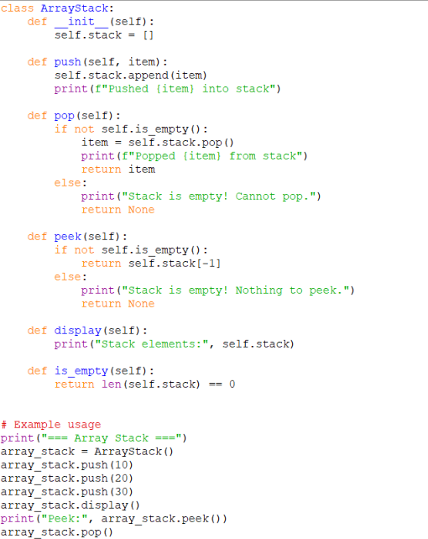
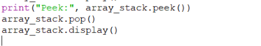
Output :
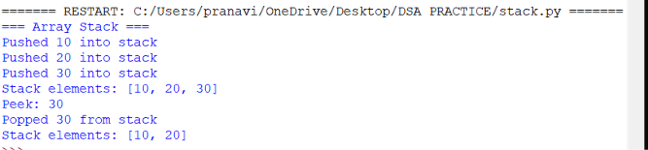
EXPLAINATION :
Stack using Array
- Push: Adds an element to the end of the list (append()).
- Pop: Removes the last element (pop()).
- Peek: Returns the last element without removing it.
- Display: Prints the list.
Stack using Linked List
- Push: Creates a new node and links it to the current top.
- Pop: Removes the top node and updates the pointer.
- Peek: Returns the data of the top node.
- Display: Traverses the linked list from top to bottom.

